**Gippius, Zinaida (ГИППИУС, ЗИНАИДА) (1869-1945)**

Zinaida Nikolaevna Gippius (Hippius) was a poet, prose writer, playwright, literary critic, religious thinker, and editor. Together with her husband Dmitry Merezhkovsky (1865-1941) and fellow poet Valery Briusov (1873-1923), she co-founded the Symbolist Movement in Russia. In fin-de-siècle St. Petersburg she hosted an influential literary salon and was one of the major organizers of the famed Religious-Philosophical Meetings (1901-1903). She established and edited the journal *The New Path* (Novyi put; 1903-1905) in which she and her husband publicized their Neo-Christian beliefs, printed the works of their fellow Symbolists and reported on their Religious-Philosophical Meetings. After 1919, when the couple was forced to leave Bolshevik Russia, Gippius continued her literary and religious activities in the Russian émigré community in Paris, France, where she died in 1945.

**Timeline of Life and Most Important Works Published During Lifetime**

1869: born in the town of Belyov in the Tula province

1889: marries Dmitry Merezhkovsky in Tiflis and moves to St. Petersburg

1890: launches her literary career by publishing poetry and prose in St Petersburg journals

1896: publishes her first book of short stories, *New People: Stories, First Book*

1901-1903: initiates and plays a key role in the St. Petersburg Religious-Philosophical Meetings

1903-1905: establishes, edits and contributes to the journal *The New Path* (Novy put)

1904: publishes her first book of poetry, *Collection of Poems (1889-1903)*

1906-1908: first political exile; lives in Paris in a quasi-religious “brotherhood of three” (Gippius-Merezhkovsky-Filosofov)

1908: publishes a collection of literary criticism, *Literary Diary* (Literaturny dnevnik)

1910: publishes her second book of poetry, *Poems. Book 2. 1903-1909*

1919: leaves Soviet Russia for Poland

1920: moves to Paris

1925: publishes her reminiscences, *Living Faces* (Zhivye litsa)

1926-1939: initiates and hosts a literary and philosophical society, “The Green Lamp” (Zelenaya lampa)

1938: publishes her last collection of poetry, *Radiance* (Siyaniya)

1945: dies in Paris

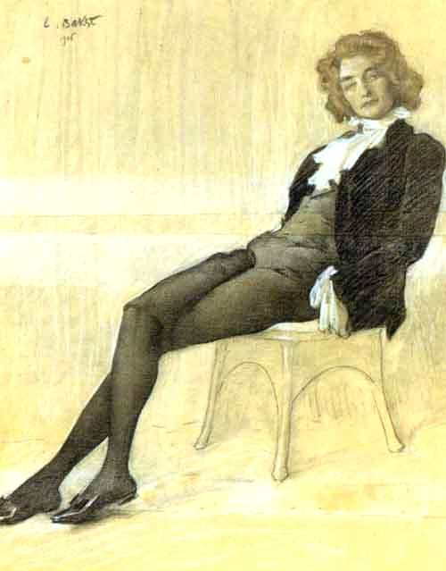

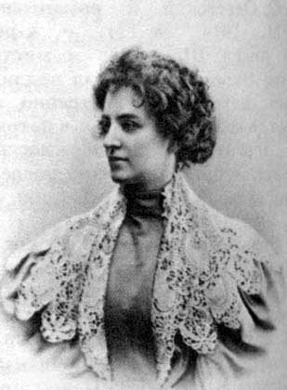Zinaida Gippius was born on November 20, 1869 (November 8 – old style), in the town of Belyov in the Tula province. Her family moved frequently due to her father’s job as the Procurator-General of the Senate, and Gippius received her education mostly at home. In 1888 in the resort town of Borjomi, Gippius met the St. Petersburg poet and philosopher Dmitry Merezhkovsky, four years her senior. The couple married in Tiflis (Tbilisi) in early 1889 and moved to St. Petersburg where Gippius soon emerged as a poet and a prose writer. Together with Merezhkovsky, Gippius played a major role in the Russian capital’s literary and religious life. She hosted an influential literary salon and was one of the major organizers of the famous Religious-Philosophical Meetings (1901-1903), which sought to establish a dialogue between the so-called ‘new religious mind’ (represented by Gippius, Merezhkovsky, Rozanov, Filosofov, and others) and high-ranking Russian Orthodox clergy. By early 1903, Gippius founded and became a major editor and contributor to the journal *The New Path* (Novyi put), where she published the works of fellow Symbolists, as well as reports of the Religious-Philosophical Meetings. It was in this journal that Gippius inaugurated the long and successful career of literary critic Anton Krainy, one of her best-known pseudonyms, which she used for her literary criticism until the end of her life. Although Gippius published many short stories and several novels, she was better known and much more appreciated for her poetry, which she published in various periodicals starting in 1888. Her first collection of poems (1889-1903) was released in 1904 by the Moscow-based Scorpion publishing house, and it was favorably reviewed by critics in the Symbolist circle (N. Abramovich, V. Briusov, In. Annensky) and negatively by their opponents. Together with her husband Merezhkovsky, Gippius frequently travelled to Western Europe and lived for extended periods of time in Italy, Germany, and France. In 1901 the couple formed a quasi-religious union with their close associate and friend Dmitry Filosofov (1872-1940), and this “brotherhood of three” (troebratstvo) became the core of their new, domestic Church that was aimed at renovating Christianity and traditional marriage along modernist lines. In 1906, after the failure of the 1905 Revolution, the trio went into political exile and lived in Paris, sharing the same apartment and co-authoring and publishing *The Tsar and Revolution (Le Tsar et la Revolution*, 1907) and the play “Poppy Blossom” (Makov tsvet, 1908). In 1908, after two and a half years of exile, the trio returned to St. Petersburg, where Gippius’ collection of critical essays, titled *Literary Diary* (Literaturny dnevnik), came out. This collection included essays previously published in various periodicals under the pseudonym Anton Krainy, and it had both the author’s name and her pseudonym on its cover.

Zinaida Gippius in the early

1910s

Portrait of Zinaida Gippius

by Leon Bakst, 1906.

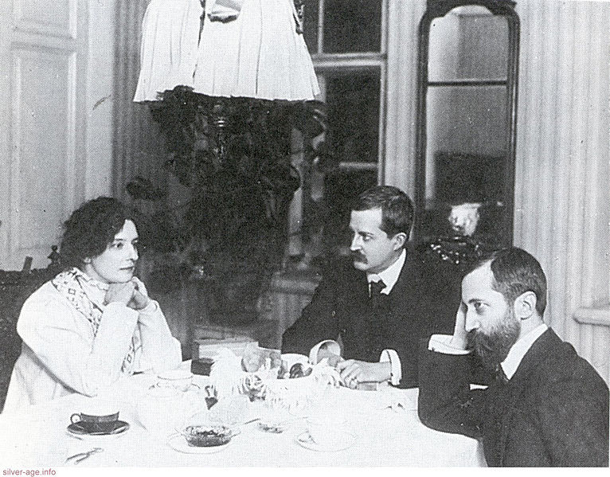At the outbreak of World War I, Gippius took an active stance against Russia’s involvement in the war, but by 1916, her initial anti-war activism had given way to acceptance of the war on the basis that it was a sign of the approaching revolution and apocalypse. In December 1919 Gippius and Merezhkovsky (along with Filosofov and their secretary V. Zlobin) left Soviet Russia via Poland. Together with revolutionary Boris Savinkov, they tried to organize military opposition to Bolshevism in Poland, but their attempts failed. In 1920 Gippius, Merezhkovsky and Zlobin left Warsaw and settled in Paris, where Gippius continued her literary activities, contributing to various émigré periodicals. In 1925 she published her reminiscences, *Zhivye litsa* (Living Faces), and in 1926 she organized a literary and philosophical society called ‘The Green Lamp’ (Zelenaya lampa), whose discussions centered on literary, religious, and political matters. Gippius’ volume of poetry *Siyaniya* (Radiance) appeared in 1938. Her 52-year marriage with Merezhkovsky, which most biographers have perceived as an intellectually fertile union of two creative personalities of nontraditional sexuality, ended with Merezhkovsky’s death in 1941, which Gippius never psychologically overcame. She died in Paris on September 9, 1945, and was buried in the Sainte-Geneviève-des-Bois Russian Cemetery outside of Paris, side by side with her husband, under one tombstone. Her book about her husband, *Dmitrii Merezhkovskii,* was published posthumously in 1951.

Gippius, Filosofov and Merezhkovsky

in 1920.

**References and Further Reading**

**Major works by Zinaida Gippius published during her life**

**Poetry:**

Collected Poems: 1889–1903 (Sobranie stikhov: 1889-1903), *[1904]*

Collected Poems: Second Book *(Sobranie stikhov: kniga vtoraya), [1910]*

Final Poems: 1914–1918 *(Poslednie stikhi. 1911-1918), [1918]*

Poetic Diary: 1911–1921 *(Stikhi: dnevnik), [1922]*

Radiances *(Siyaniya), [1938]*

**Prose:**

New People: Stories *(Novye lyudi), [1896]*

*The Winners (Pobediteli), [1898]*

The Mirrors: Second Book of Stories *(Zerkala. Vtoraya kniga rasskazov), [1898]*

*Sacred Bood. A Play (Svyataya krov. Drama), [1901]*

Third Book of Stories *(Tretya kniga rasskazov), [1902]*

The Scarlet Sword. Stories *(Alyi mech. Rasskazy), [1906]*

Literary Diary: 1899-1907 *(Literaturnyi dnevnik: 1899-1907), [1908]*

In Black and White: Fifth Book of Stories *(Chernoe po belomu. Pyataya kniga rasskazov), [1908]*

The Devil's Doll: A Biography in Thirty-three Chapters *(Chertova kukla. Zhizneopisanie v 33-x glavakh), [1911]*

Lunar Ants: Sixth Book of Stories *(Lunnye muravyi. Shestaya kniga rasskazov), [1912]*

Roman-Tsarevitch: The History of One Beginning *(Roman-Tzarevich. Istoriya odnogo nachinaniya), [1913]*

The Green Ring: A Play in Four Acts with afterword "Green-White-Scarlet" *(Zelenoe koltso. Pyesa v chetyrekh deistviyakh s poslesloviem “Zelenoe-aloe-beloe”), [1916]*

Heavenly Words and Other Stories *(Nebesnye slova i drugiye rasskazy), [1921]*

Living Faces *(Zhivye litza), [1925]*

The Blue Book: Petersburg Diary, 1914–1918 *(Sinyaya kniga. Peterburgsky dnevnik: 1914-1918), [1929]*

**Memoirs and diaries published posthumously:**

Dmitrii Merezhkovskii, *[1951]*

*Contes d’amour. The Diary of Love Stories: 1893-1904 (Contes d’amour. Dnevnik lyubovnykh istoriy. 1893-1904), [1969]*

*About the Major Task; 1901-1943 (O glavnom: 1901-1943), [1970]*

*Black notebooks: 1917-1919 (Chernye tetradi: 1917-1919), [1992]*

**Selected works about Zinaida Gippius**

Zlobin, Vladimir, *A Difficult Soul* (Tyazhelaya dusha), Washington: Viktor Kamkin, Inc., [1970]; English translation, edited, annotated and introduced with an essay by S. Karlinsky, University of California Press, [1980]

(Although V. Zlobin lived in the Gippius-Merezhkovsky household in Paris for almost 25 years and was their personal secretary, he is not a reliable memoirist. He mixes the facts of Gippius’ life with his dubious interpretations. For example, he overstresses the poet’s ‘obsession’ with the Devil and he defines her love for Filosofov as ‘noumenal and transcendental.’)

Pachmus, Temira, *Zinaida Hippius. An Intellectual Profile*, Southern Illinois University Press, [1971] (As the reliable holder of Gippius and Merezhkovsky’s émigré archive, Pachmus occupied a major role in Gippius studies in the second half of the 20th century. The breadth of her factual information about Gippuis, though, is not matched by the depth of her scholarly analysis. The scholar avoids addressing issues of Gippius’ nontraditional gender and sexuality, and she overemphasizes Gippius’ loyalty to the Russian Orthodox Church.)

Korolyova, N.V., *Zinaida Nikolaevna Gippius: New Materials and Research* (Zinaida Nikolaevna Gippius. Novye materialy. Issledovaniya), Moscow, [2002] (The first collection of scholarly materials about Gippius to be published in post-Soviet Russia, it includes Gippius’ unpublished correspondence with Soviet writer M. Shaginyan and others, as well as articles about her relations with G. Chulkov and A. Akhmatova.)

Presto, Jenifer, *Beyond the Flesh: Alexander Blok, Zinaida Gippius, and the Symbolist Sublimation of Sex*, Univ. of Wisconsin Press, 2008 (A study of sexual mythologies in Russian Symbolism and an analysis of Gippius’ works through the lens of Symbolism and some contemporary gender theories.)

Nikolyukin, A. N. (collected and edited by), *Z. N. Gippius: pro et contra*, Russian Christian Academy, St. Petersburg, [2008] (The most comprehensive collection of texts about Gippius’ life and works, totalling more than 1,000 pages, originally published in the pre-revolutionary and émigré Russian press.)

**Tatiana Osipovich, Lewis and Clark University**

**Photographs**

Figure 1:

Portrait by Leon Bakst, 1906:

<http://images.google.ca/imgres?q=gippius&num=10&hl=en&biw=1024&bih=687&tbm=isch&tbnid=8LwAT3g1dWj8rM:&imgrefurl=http://justneville.tumblr.com/post/4090705810&docid=LRCeph4_HvqycM&imgurl=http://25.media.tumblr.com/tumblr_limt0cPzY61qg70jqo1_500.jpg&w=500&h=639&ei=iIApUNn1Ha6WjAKA4oGIDw&zoom=1&iact=hc&vpx=673&vpy=88&dur=1148&hovh=254&hovw=199&tx=122&ty=120&sig=103608728139884508197&page=1&tbnh=156&tbnw=132&start=0&ndsp=19&ved=1t:429,r:4,s:0,i:85>

Figure 2:

Zinaida Gippius in the early 1910s:

<http://img1.liveinternet.ru/images/attach/c/0//53/455/53455146_1262876227_gippiusz.jpg>

Figure 3:

Gippius, Filosofov and Merezhkovsky in 1920:

<http://cs.wikipedia.org/wiki/Soubor:Gippius_Filosofov_Merezhkovsky.jpg>

**Films**

*Zinaida Gippius. Dark Glass.* (Zinaida Gippius. Tyomnoe steklo), documentary by “Kultura” TV channel, dir. A. Sadulovsky, [2004]

<http://gippius.com/video/temnoe-steklo.html>